**PROJECT REPORT TEMPLATE**

**INTRODUCTION**

* 1. Overview: A subscriber to a channel on the video-sharing YouTube is a user who has chosen to receive the channel's content by clicking on that channel's "Subscribe" button, and each user's subscription feed consists of videos published by channels to which the user is subscribed.

The channels are ordered by number of subscribers; those whose displayed subscriber counts are identical are listed so that the channel whose current growth rate indicates that its displayed subscriber count will exceed that of the other channel is listed first. Eg: T-Series has surpassed 200 million subscribers.

* 1. Purpose: This makes your subscribers more likely to watch

the videos that are being upload. This gives creators access monetization features such as advertising, fan funding and merchandise sales.

**PROBLEM DEFINITION & DESIGN THINKING**

**2.1 Empathy Map**

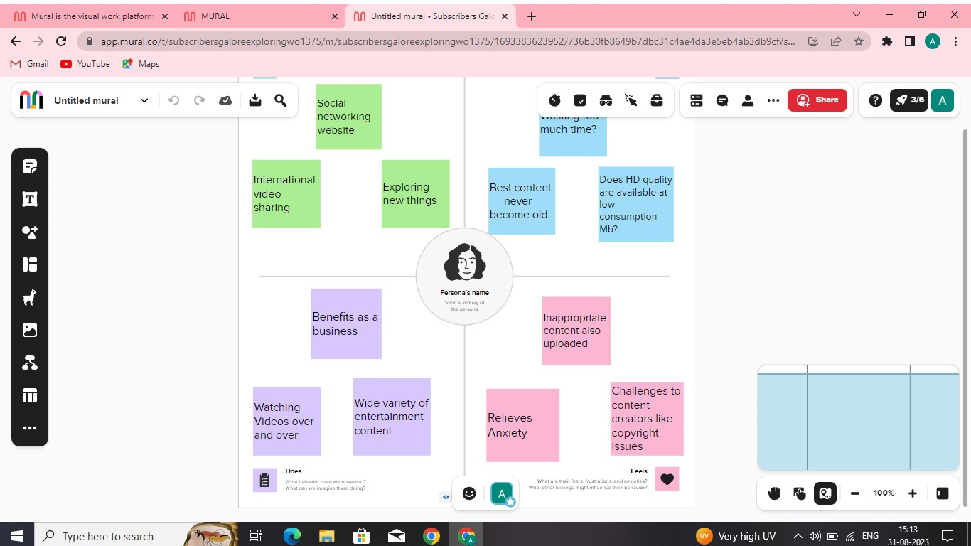

**2.2 Ideation and Brainstorming Map**

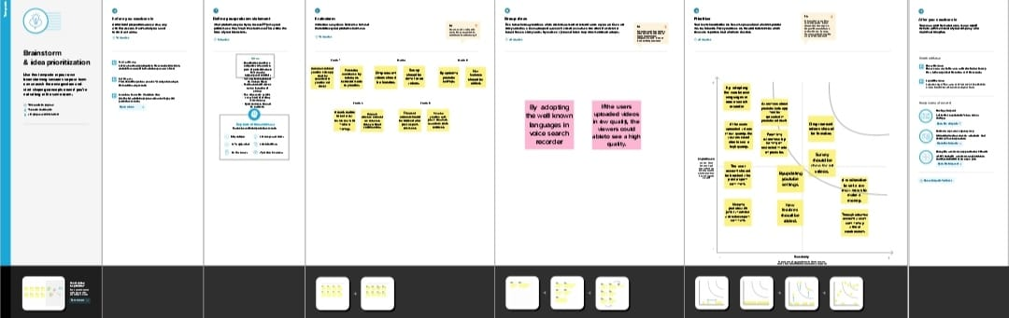

**RESULT**

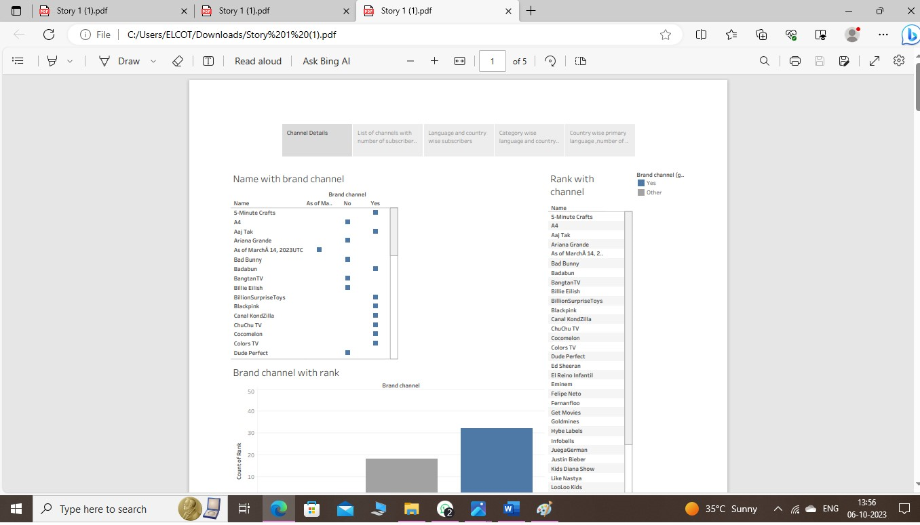

**ADVANTAGES**

1)YouTube as an information disseminating platform for students.

2)YouTube's user-friendliness.From pet lovers to homemakers, anyone can find content suitable to their interests.

3)Easy Earning is at the very top of the list of YouTube benefits for Vloggers.

**DISADVANTAGES**

1)Ads are drawbacks of YouTube for the audience. it requires you to pay a charge if you would like to view ads-free content.

2)Defamation and Bullying, many users misuse the platform to spread hate and chaos via content, causing tension between users.

3)Obscenity one of the biggest drawbacks that YouTube has.

**APPLICATIONS**

1. Create a community.
2. Youtube Channels.
3. Can learn many skills.
4. Improved Career prospects.
5. Youtube kills boredom.

**CONCLUSION**

There are many positive aspects to keep in mind about YouTube in comparison to the negatives. By analyzing the positives and negatives of YouTube, it is possible to get an idea of the number of users who receive the information and what percentage of them are misleading. The whole thing is based on people's interests, which is the reason YouTube exists, and so do YouTube channels.

**FUTURE SCOPE**

The future of YouTube is all about growth, innovation, and improving the user experience. We can expect new features, better algorithms, and more opportunities for content creators. YouTube will continue to evolve and provide exciting possibilities for both viewers and creators. So get ready for an even more amazing YouTube journey ahead!